Installation and User Guide

# Prerequisite

* MacOS (The system we developed on)
* Computer with internet access
* Anaconda installed
* Pycharm installed

# Deployment

1. To get started, you can download the source code at

<https://github.com/xiaohuihong/PLP-PM-2022-11-07-GRP-01-Virtual_Personal_Assistant.git>

1. Create a python 3.7 environment as shown in the following. You can replace the <env> with any name you want to use.

| conda create -n <env> python=3.7 conda activate <env> |
| --- |

1. In the code folder, run the below commands to install the packages.

| pip install -f --user numpy pandas nltk bs4 python-telegram-bot spacy==2.3.5 tensorflow keras seaborn wordcloud scipy transformers SentencePiece sklearn chatterbot==1.0.4 chatterbot_corpus  pip3 install torch torchvision torchaudio --extra-index-url https://download.pytorch.org/whl/cu116 python -m spacy download en conda install -y numpy jupyter notebook |
| --- |

1. Go to the question_answering folder,

download the dataset zip file from <https://drive.google.com/file/d/117wHqq5Cb4wDjqrMr0uXQ_FbBQSFThxZ/view?usp=sharing>

download the model zip file from <https://drive.google.com/file/d/1PvJPqAWSD0zygI-cBWkHn2YsZOVou0E1/view?usp=sharing>

And unzip these two files into the question_answering folder.

Then the ./question_answering/dataset folder would be like

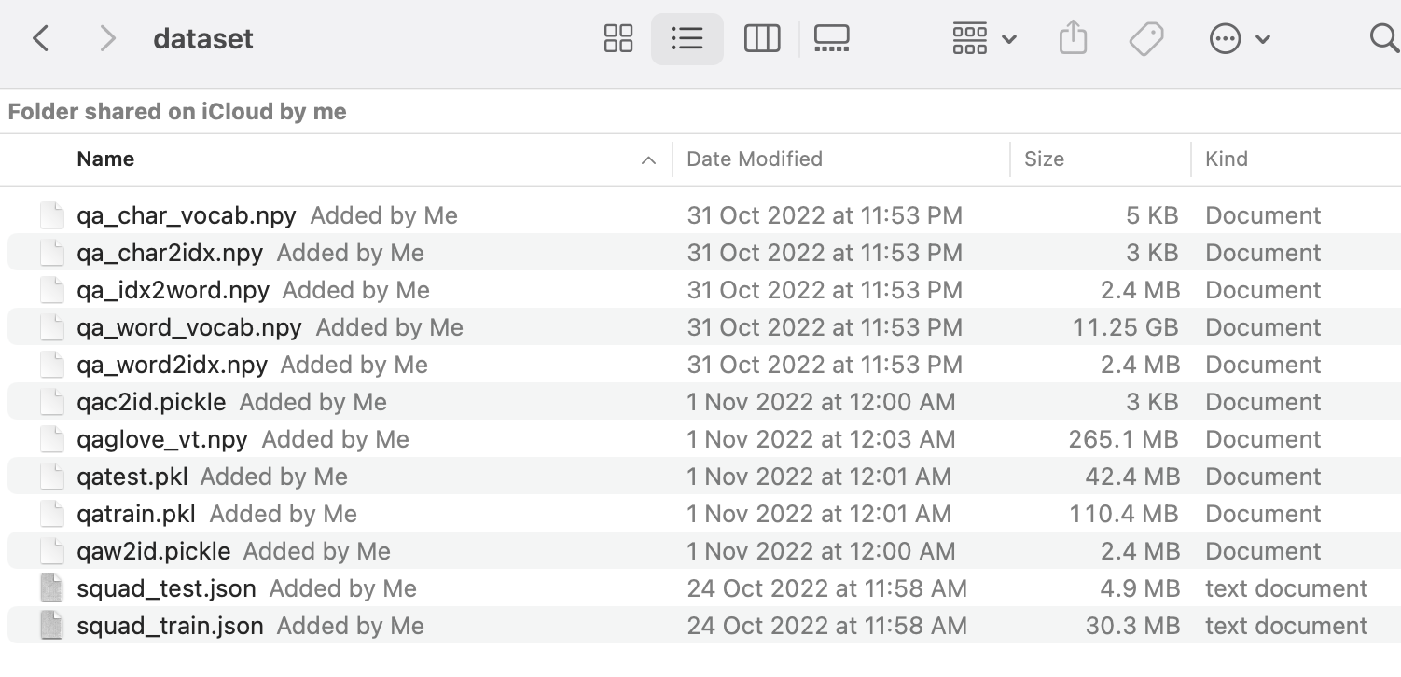

Then the ./question_answering/model folder would be like

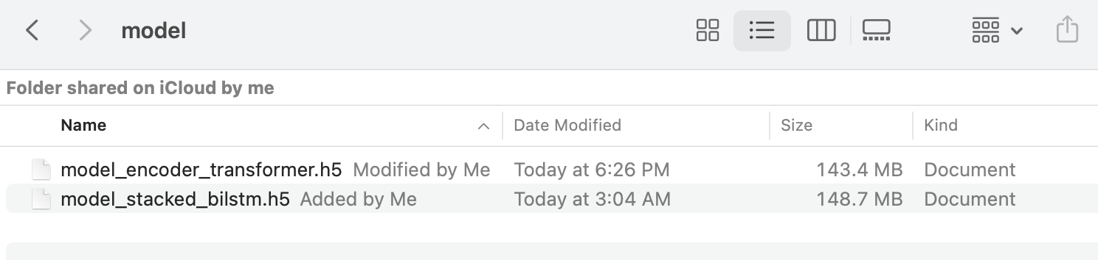

Download the glove file from <https://nlp.stanford.edu/data/glove.840B.300d.zip>

And unzip the file “glove.840B.300d.txt” into dataset folder, then the final dataset folder is like

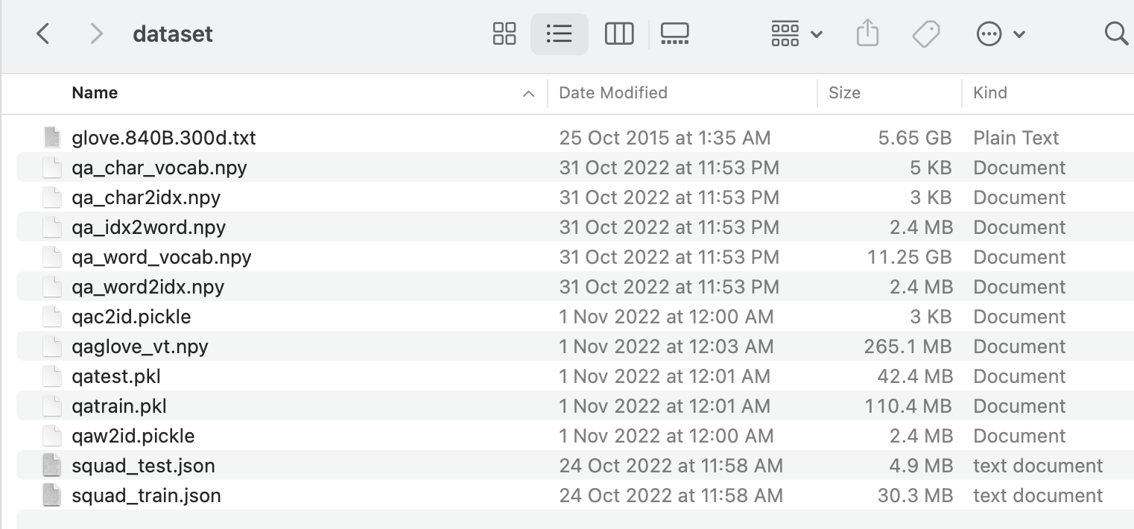

1. Go to the text_summarization folder,

download the dataset zip file from

<https://drive.google.com/file/d/1D6gKuxjNpjVU_KB16kaSI7-p75uwQQ2h/view?usp=sharing>

And unzip the file into text_summarization folder, then the ./text_summarization/model folder is like

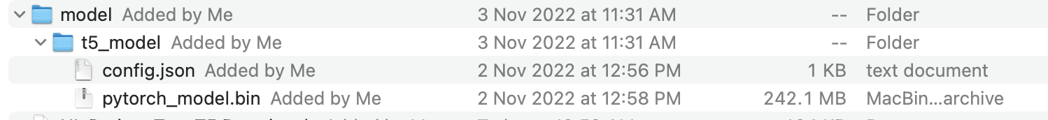

1. Open Pycharm, click the “Open” button.

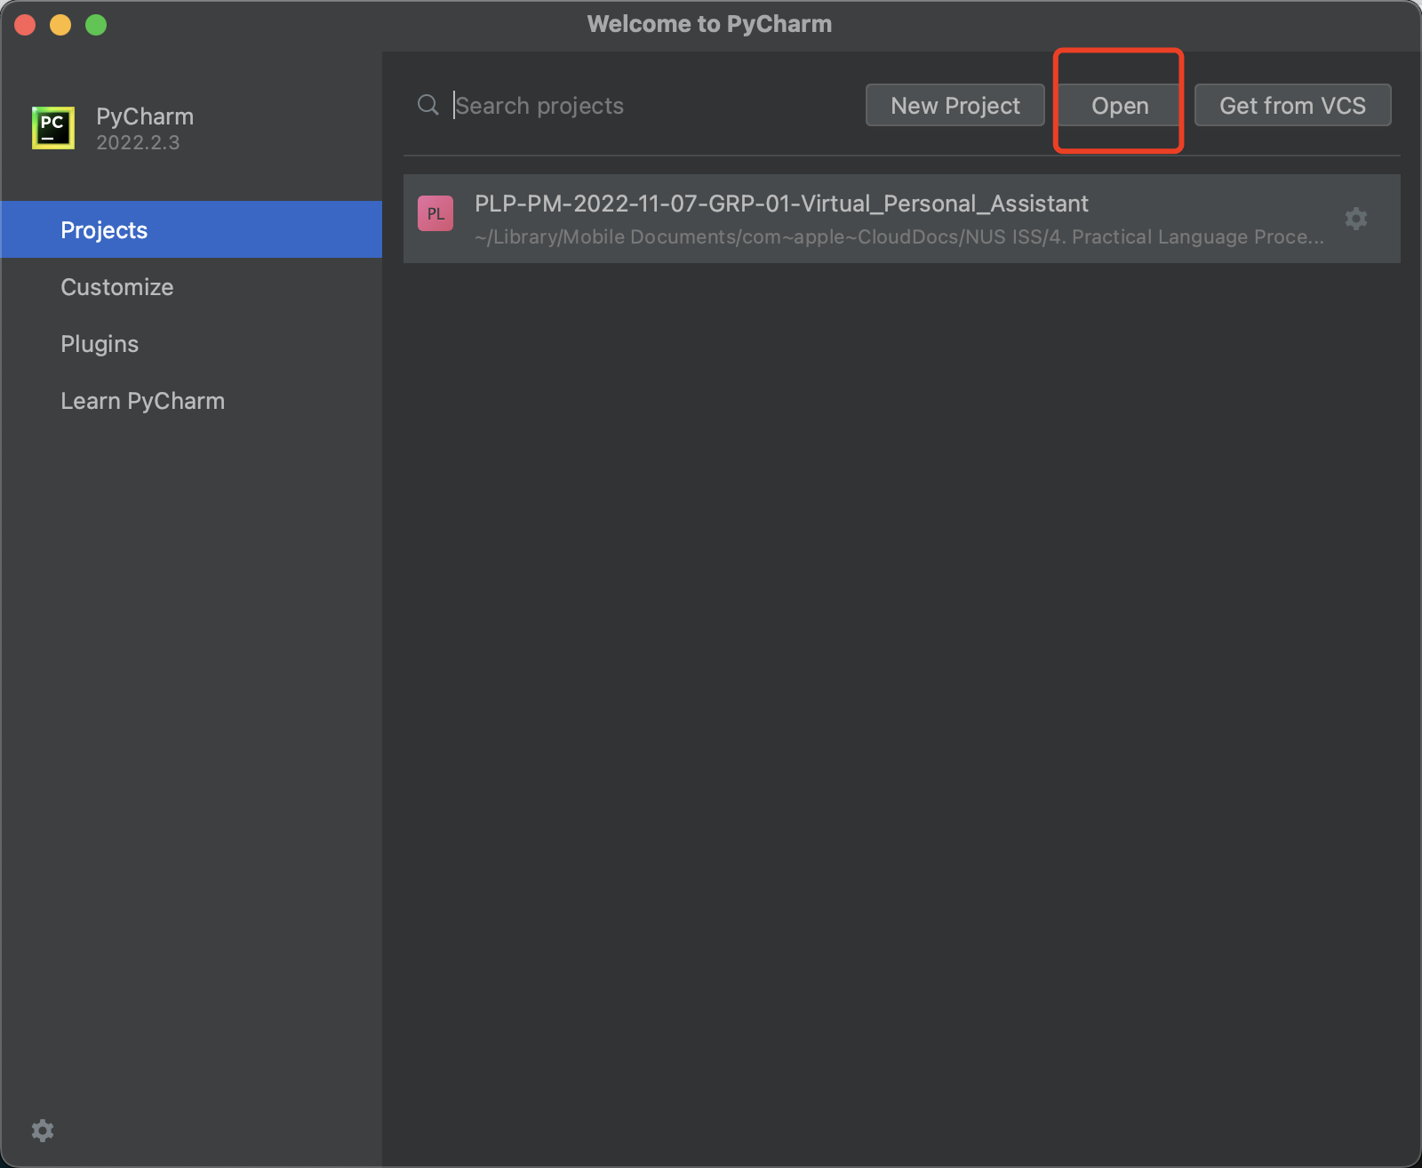

Select the project parent folder.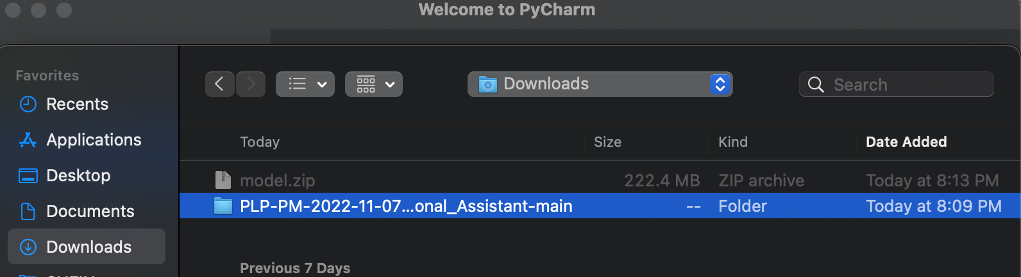

Click on the “Trust Project”.

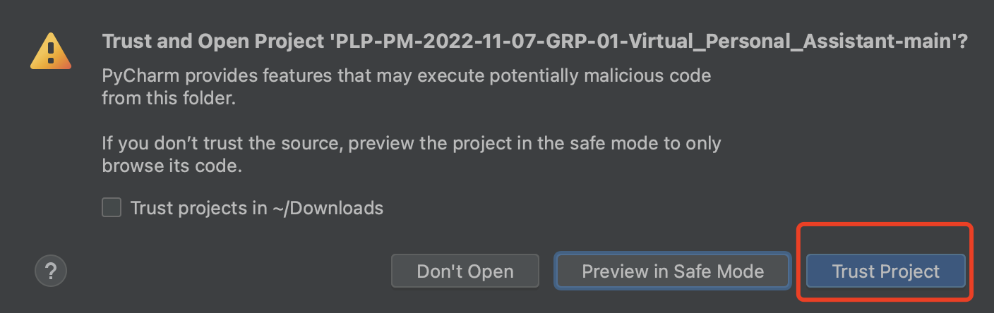

Select the “Preference…” in the PyCharm menu.

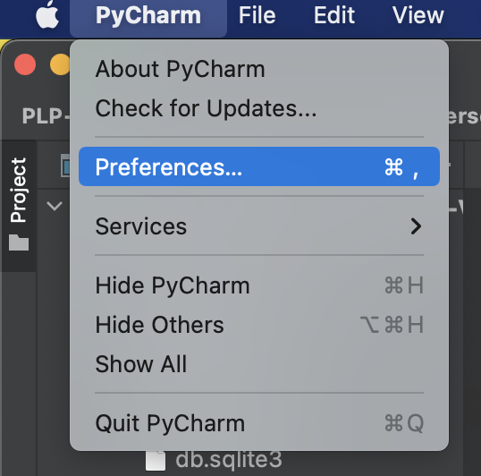

Select the “Python Interpreter” under the current project.

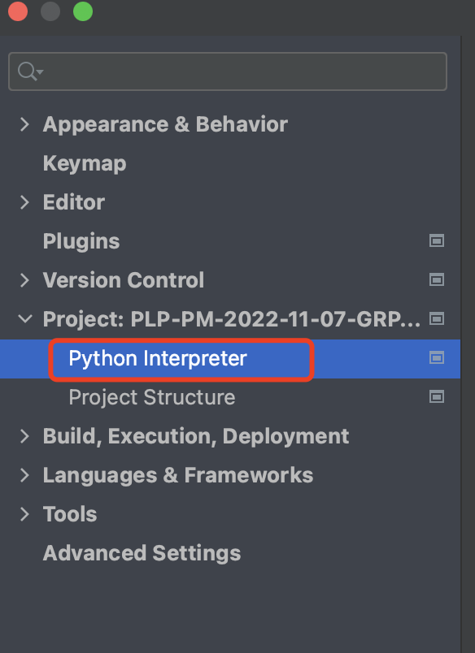

Select “Add Local Interpreter…”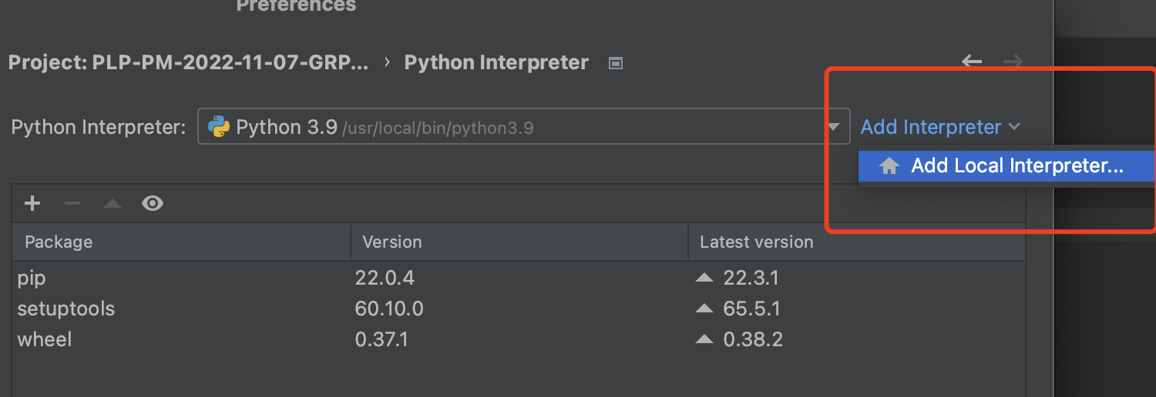

Choose the “Conda Environment” and select the env you created in the step2. And Click OK to apply the changes.

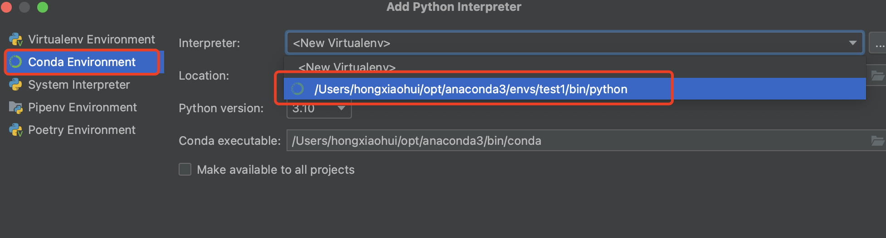

Choose the server.py under the telegram_bot folder, and Run it.

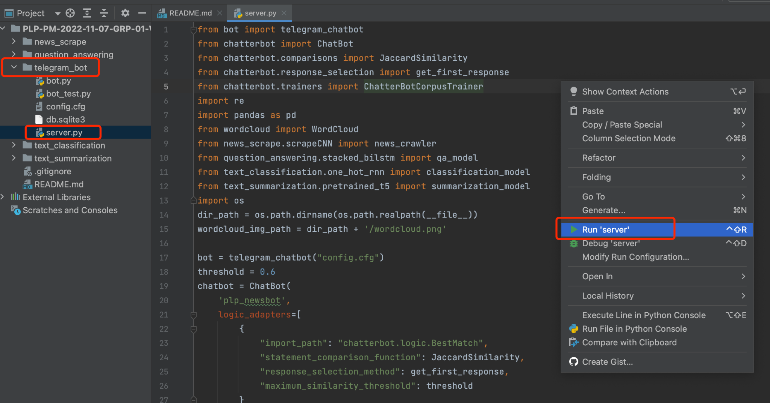

From the running output, you can see that the chatbot is alive…

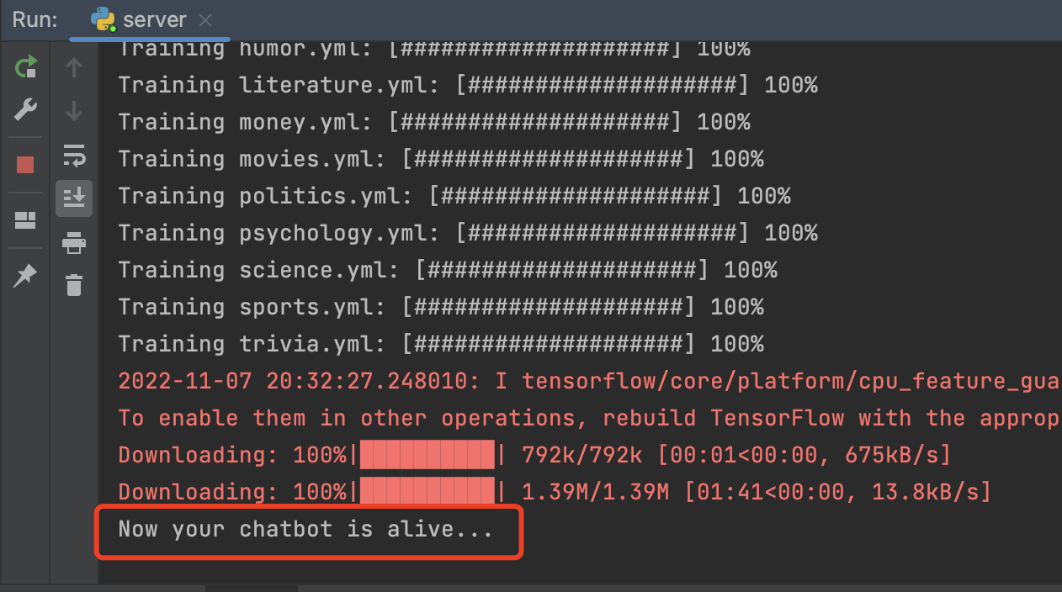

1. Open this link [t.me/plp_newsbot](http://t.me/plp_newsbot) to add this bot account into your telegram. And you would find this account

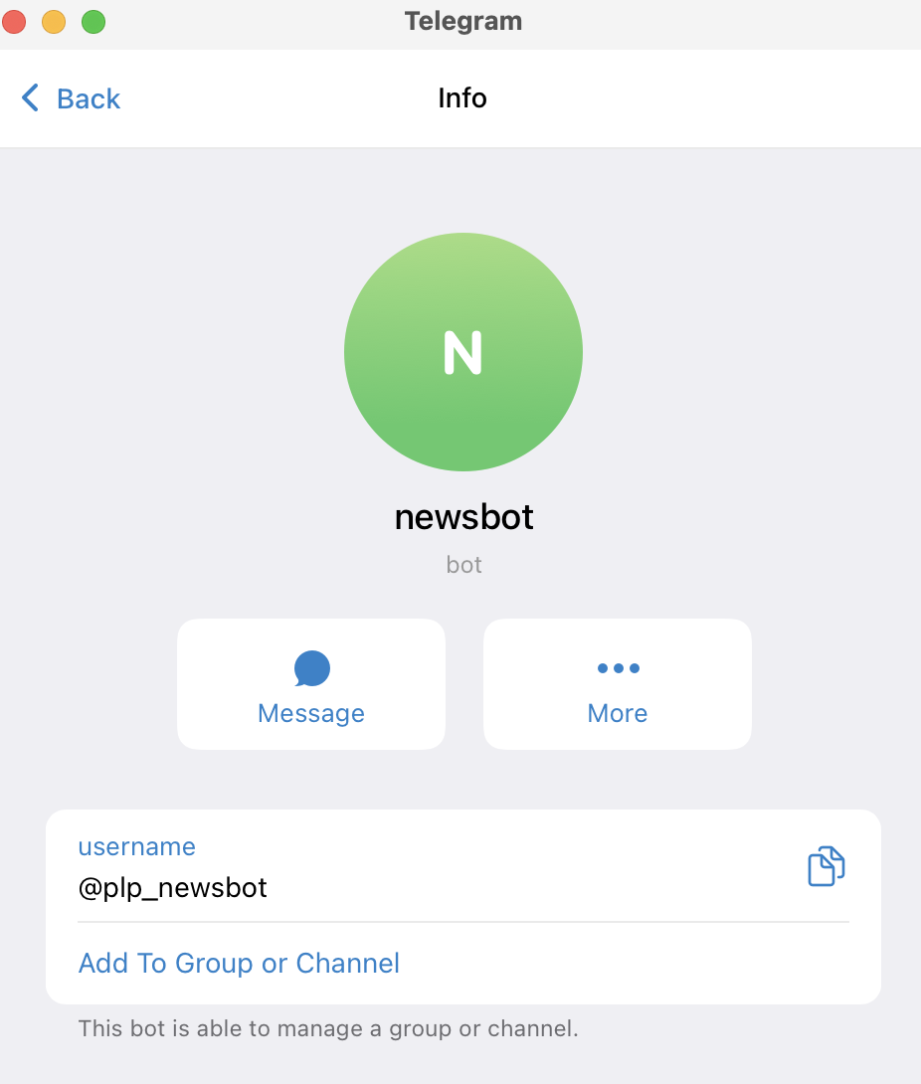

1. Now you can communicate with our system

